Manneken Pis’ Big Book
Marie-Louise BRUYÈRE and Yoneko NURTANTIO,
www.nurtantio-projects.com/Manneken_Pis_EN.html

[What? How?]
"Manneken Pis’ Big Book" is the 1st book that explains with images why Manneken Pis is the statue that represents Brussels the best.
- A graphic look + short and funny texts to understand this weird symbol in 69 pages: Why is he so famous? Why is he dressed? Is it a scam? Or maybe it’s a joke? A Belgian joke, then! And by the way, what’s Belgian humor? Does “Belgitude” really exist? What if Manneken Pis was a symbol of surrealism?
→ "Their book is ‘big’ but small; written as a joke but very serious; seemingly ‘simple’ but really much elaborated.” (Roel Jacobs, historian)
- Supported by the Brussels-Capital Region and the French Community Commission (COCOF)
- Available in 3 languages (EN-FR-NL)
- Price: 12€
- Marie-Louise BRUYÈRE and Yoneko NURTANTIO, Manneken Pis’ Big Book, Foreword by Roel JACOBS, translated from French by Yoneko NURTANTIO and Allison OCHSENMEIER (revision), Brussels, ASBL Nurtantio Projects, 2017, 69 pp., ISBN (= EAN) : 978-9-08-278182-3
[Why?]
March 22, 2016. Brussels is injured by two terrorist attacks. Against terror, Belgian people decide to stay united.
Dozens of caricatures circulate widely. Most of them show the same symbol: a peeing little boy with a bare navel.
Is Manneken Pis a symbol for liberty? For sure.
Self-mockery, resistance, humility, surrealism… By writing “Manneken Pis’ Big Book” (from which the title itself is ironic), the authors wanted to share through this statue the particular mindset of Brussels, with lots of tenderness.
[Who?]
- The mother-daughter team formed by Marie-Louise BRUYÈRE and Yoneko NURTANTIO, is author of the book "Zéro gaspi ! La méthode pour jeter moins et vivre mieux" (ed. Larousse, 2017). Several thousands of exemplars of this book where sold in the 8 months after its release. Today, “Zéro gaspi !” makes reference in its field.
+ A foreword signed by Roel JACOBS, recognized specialist of the history of Brussels.

- "Manneken Pis’ Big Book" was produced with the participation of many contributors, in particular: Gwenny Nurtantio (artistic direction), Nathalie Diependaele (winner of the graphic design contest organized to define the cover of the book), Frédéric Chaltin (graphic revision), Roel Jacobs (author of the foreword), Yuelan Liu, Erwann Gauthier and Christopher Charles (3 visuals), Louis Maeyart and Allison Ochsenmeier (revision of NL and EN translations).
- The book also brings together works, quotes and anecdotes from many famous Belgians, including comedians and (street) artists.

[Where?]
The book is published by the ASBL Nurtantio Projects, a family-run non-profit organization, which aims to propose ways to a more fulfilling lifestyle. In two parts:
- How to broaden your horizons and amaze yourself on a daily basis? An aspect developed in "Manneken Pis’ Big Book" and in the articles published on the website www.nurtantio-projects.com)
- How to optimize your standard of living with the salary you have? This is the conso component at the heart of the JUST KEEP IT challenge (www.justkeepit.be) and the book "Zéro gaspi ! La méthode pour jeter moins et vivre mieux" (ed. Larousse, 2017)
The book is available at Fnac, at Club / Standaard Boekhandel and in many shops around the city center of Brussels. To access the complete list of points of sale, other information and the order form: www.nurtantio-projects.com/Manneken_Pis_EN.html

Contact: nurtantio.projects[at]gmail.com

Illustrations

- Cover (illustration : Nathalie Diependaele)
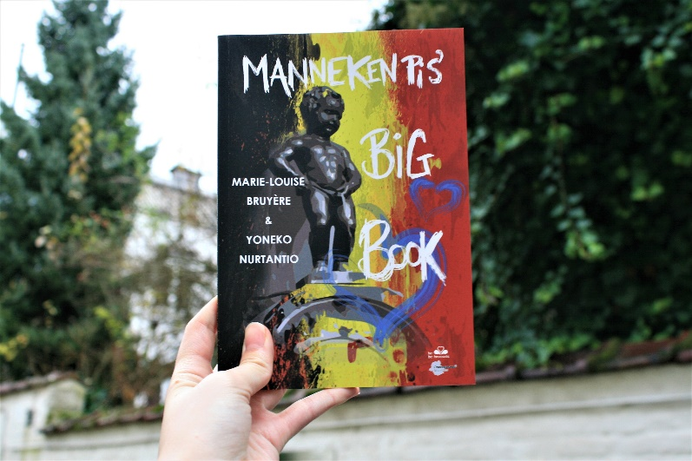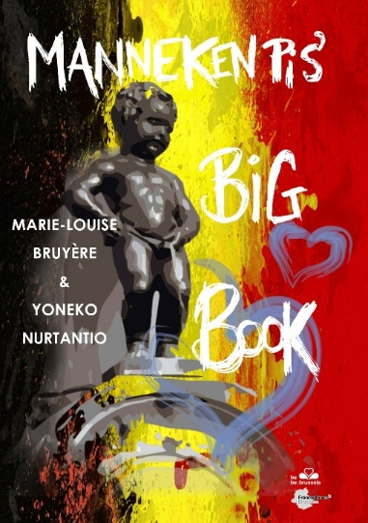

- Example of page : "Is that art?" - Extract from "Manneken Pis’ Big Book". Illustrations : Erwann Gauthier and Afrânio Fonseca De Paula (photo : Erwann Gauthier)
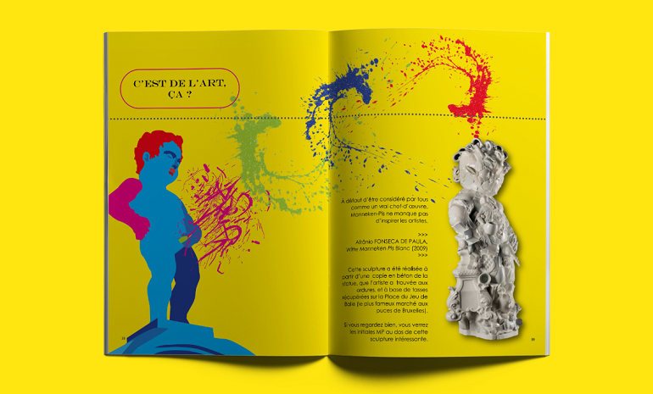

- A : Gwenny Nurtantio, artistic direction and translation (NL)
B : Marie-Louise Bruyère and Yoneko Nurtantio, authors
C : Marie-Louise Bruyère (credits : Grégory Autiquet ©)
D : Yoneko Nurtantio (credits : Grégory Autiquet ©)
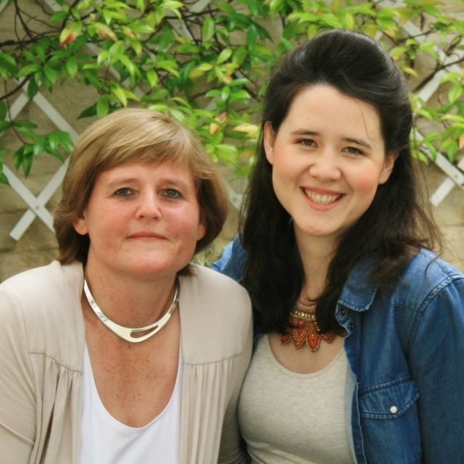
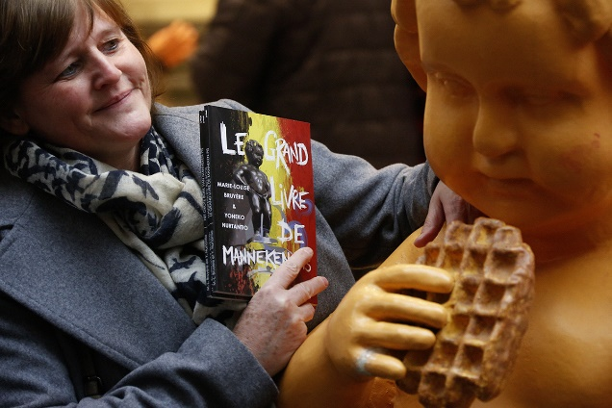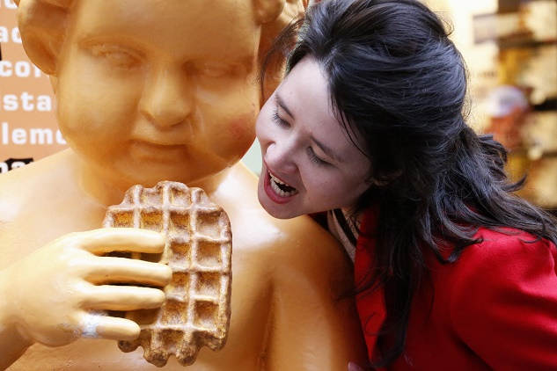

- With Jean-Michel Zecca (BEL RTL) and with the Belgian fashion designer Jean-Paul Lespagnard
